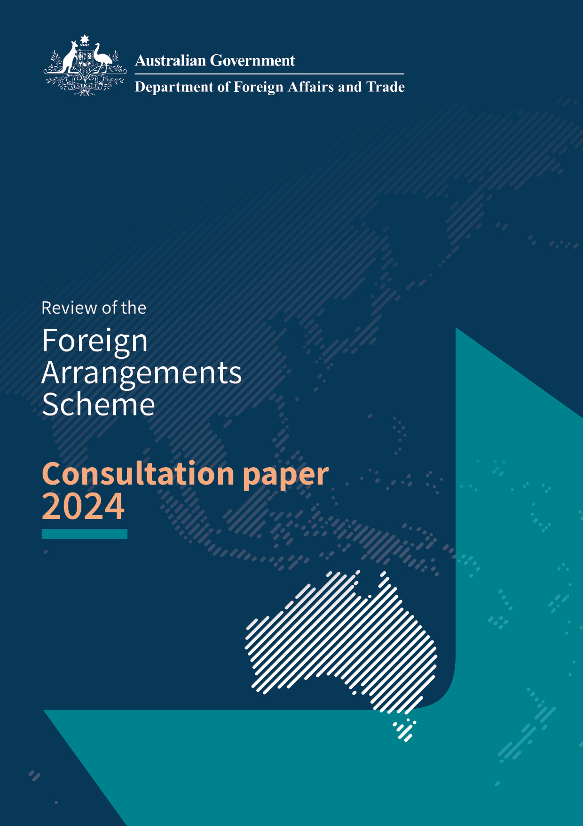
© Commonwealth of Australia 2024
The material in this publication is licensed under a Creative Commons Attribution 4.0 International Licence (creativecommons.org/licenses/by/4.0/), with the exception of:
- The Commonwealth Coat of Arms
- The Department of Foreign Affairs and Trade logo, and any other material protected by a trademark
- Any image where credit is not directly provided to the Department of Foreign Affairs and Trade.
Creative Commons Attribution 4.0 International Licence is a standard form license agreement that allows you to copy, distribute, transmit and adapt this publication provided that you attribute the work. The full legal code for the licence (which includes any relevant licence conditions) is available on the Creative Commons website accessible by using this link:
- creativecommons.org/licenses/by/4.0/legalcode.
The Commonwealth’s preference is that you attribute this publication (and any material sourced from it) using the following wording:
- Foreign Arrangements Scheme Consultation Paper. Commonwealth of Australia 2024. Licensed from the Commonwealth of Australia under a Creative Commons Attribution 4.0 International Licence.
Written requests for permission or enquiries should be emailed to: AFRA.Review@dfat.gov.au
Third party copyright
Some material in this consultation paper, made available under the Creative Commons Licence framework, may be derived from material supplied by third parties. In these instances, the work will be clearly labelled with the source of the original material.
If a third party holds copyright in materials in the consultation paper, the copyright remains with that party and their permission may be required to use the material.
Use of the Coat of Arms The terms under which the Coat of Arms can be used are detailed on the website of the Department of the Prime Minister and Cabinet:
- https://www.pmc.gov.au/resources/commonwealth-coat-arms-information-and-guidelines
Contact information
Enquiries about the consultation paper are welcome and should be directed to:
Foreign Arrangements Branch
Department of Foreign Affairs and Trade
R.G. Casey Building, John McEwen Crescent Barton ACT 0221
Phone: 02 6261 1111
Email: AFRA.Review@dfat.gov.au
Website: www.foreignarrangements.gov.au
Accessibility
Our website (www.foreignarrangements.gov.au) contains an accessible version of this consultation paper.
The Translating and Interpreting Service is an interpreting service provided by the Department of Home Affairs to provide interpreting services for people who do not speak English and for agencies and businesses that need to communicate with their non-English-speaking clients. Call 131 450 or visit www.tisnational.gov.au.
Services for people with hearing or speech impairments:
- TTY users—call 133 677 then ask for 02 6141 6666
- Speak and listen users—call 1300 555 727 then ask for 02 6141 6666
- Internet relay users—connect to the National Relay Service then ask for 02 6141 6666

Consultation process
Section 63A of the Australia’s Foreign Relations (State and Territory Arrangements) Act 2020 (the Foreign Relations Act) requires a review of the operation of the Act as soon as possible after 10 March 2024. The Government has announced the commencement of the review and has released its terms of reference (available at www.foreignarrangements.gov.au).
In order to inform the review, interested stakeholders are invited to comment on the issues raised in this consultation paper by 2 August 2024.

About the Foreign Arrangements Scheme
The objective of the Foreign Arrangements Scheme is to ensure that the Commonwealth is able to protect and manage Australia’s foreign relations by ensuring that arrangements between a state, territory, local government or university and a foreign entity do not adversely affect Australia’s foreign relations and are not inconsistent with Australia’s foreign policy.
The Foreign Arrangements Scheme enables a systematic and consistent approach to foreign engagement across all levels of government. It ensures that Australian sub-national governments, at all levels, act consistently with Australia’s foreign policy.
The Foreign Arrangements Scheme commenced on 10 December 2020 following passage of the Foreign Relations Act. Existing foreign arrangements by states, territories, local governments and universities with foreign national and sub-national governments were required to be notified to the Minister for Foreign Affairs before 10 June 2021. The Act imposes an ongoing obligation (commencing 10 March 2021) on states, territories, local governments and universities to notify new arrangements (after 10 March 2021) to the Minister.
Under the Foreign Relations Act, the Minister for Foreign Affairs must approve or refuse to approve negotiation and entry into new arrangements by core state and territory entities with foreign national governments/entities within 30 days of their notification. The Minister must give approval if satisfied that the arrangement would not adversely affect Australia’s foreign relations and would not be inconsistent with Australia’s foreign policy. If not satisfied, he or she must refuse to provide approval and the State/Territory entity will not be able to commence negotiations or enter into the arrangement. The Minister retains the discretion to cancel or vary arrangements that are in operation if he or she is satisfied that the arrangement adversely affects Australia’s foreign relations or is inconsistent with Australia’s foreign policy.
Non-core foreign arrangements must also be notified, but the Minister’s approval is not specifically required. In these cases, the Minister retains the discretion to cancel, vary, or prohibit negotiation of, or entry into, any arrangement where it would be adverse to Australia’s foreign relations or inconsistent with Australia’s foreign policy.
The Foreign Arrangements Scheme established a Public Register which includes information about foreign arrangements notified under the Scheme, including whether a decision has been made. The Public Register serves as a transparency mechanism, demonstrating the depth and breadth of international engagement carried out by states, territories, local governments, and universities.
Since the Foreign Arrangements Scheme commenced three years ago, Ministers have made over 450 decisions and over 9,000 arrangements have been published on the Public Register.
The Department of Foreign Affairs and Trade has also implemented a stakeholder engagement and outreach program to support compliance with the Foreign Arrangements Scheme and grow awareness, enhance cooperation, and foster dialogue on Australia’s foreign policy settings. This includes factsheets on the Scheme, an e-learning module, and a series of outreach initiatives in every Australian state and territory.
Further information about the Foreign Arrangements Scheme is available at www.foreignarrangements.gov.au.
Review of the Foreign Arrangements Scheme
In an increasingly complex and challenging international environment, the legislative framework that underpins the Foreign Arrangements Scheme needs to remain responsive. The Australian Government is committed to ensuring that the Foreign Arrangements Scheme remains effective in meeting its objectives.
Section 63A of the Foreign Relations Act requires a review of the operation of the Act as soon as possible after 10 March 2024. In order to inform this review, interested stakeholders are invited to provide submissions on the issues and questions raised in this consultation paper, including the terms of reference as set out below.
Terms of reference
The review must include consideration of:
- whether it is necessary or desirable to do anything to improve the operation of the Act;
- the effectiveness of the Act in meeting its objectives;
- whether the Act should be amended to implement the recommendations of the review; and
- whether a further review of the Act should be undertaken, and, if so, when.
Key outcomes
Key outcomes include a legislative framework that:
- is an effective tool that enables the Minister for Foreign Affairs to:
  - maintain oversight of Australian sub-national government and university foreign engagement;
  - take effective action where foreign arrangements adversely affect Australia’s foreign relations or are inconsistent with Australia’s foreign policy;
- is appropriately calibrated to foreign policy risks and changing foreign policy settings;
- is clear to interpret and apply;
- effectively achieves the Foreign Arrangements Scheme’s objectives;
- provides transparency of Australian sub-national government and university foreign engagement;
- promotes a greater understanding of Australia’s foreign policy; and
- does not impose greater administrative burden on stakeholders and government than is necessary to achieve its objectives.

Consultation questions
The Australian Government welcomes feedback on any aspect of this consultation paper and terms of reference. The following consultation questions, while not exhaustive, are provided to guide submissions from stakeholders.
- Has the Foreign Relations Act been effective in delivering against its objectives, to ensure consistent adherence to Australia’s foreign policy through foreign engagement?
- How could the operation of the Foreign Relations Act be improved? Are there amendments to the Foreign Relations Act that would enhance its operation?
- Are there opportunities for the Foreign Relations Act to better support international cooperation in the national interest?
- Could the Foreign Relations Act be better calibrated to address foreign policy risks and changing foreign policy settings?
- Should the scope of the Foreign Relations Act be changed to apply to a broader or narrower range of international cooperation?
- Does the Foreign Relations Act strike the right balance between achieving its objectives and the administrative requirements it places on states, territories, local governments, and universities?
- Are there additional ways that the Foreign Relations Act can improve transparency and awareness of international engagement, including through the Public Register?
- Are there opportunities to better support compliance with the Foreign Arrangements Scheme, including through publicly available information and outreach initiatives?

Making a submission
The closing date for submissions is 2 August 2024.
Submissions should be no more than twenty pages in length (including attachments) and can be sent by email to AFRA.Review@dfat.gov.au.
For accessibility reasons, responses should be submitted in Word or PDF format.
All information in submissions (including names) may be made publicly available on the Foreign Arrangements Scheme website at the conclusion of the consultation process, unless you indicate that you would like all or part of your submission to remain in confidence. If you would like only part of your submission to remain confidential, please provide this information clearly marked as such in a separate attachment.
Individuals and organisations may request to have their submission published anonymously or not published at all.
Legal requirements, such as those imposed by the Freedom of Information Act 1982, may affect the confidentiality of your submission.
Closing date for submissions: | 2 August 2024
Make submissions at: | AFRA.Review@dfat.gov.au
Enquiries: | Enquiries can be directed to the Department of Foreign Affairs and Trade at AFRA.Review@dfat.gov.au

